**Customs and Trade Solutions Working Group**

**Thursday 31/10/2024**

**Online meeting**

**Introduction**

Members were welcomed by Mark Johnson (MJ) (Chair). MJ set out what he hopes to achieve in the role and wants to ensure that these are valuable for members, and thanks members for making the time to join the meeting.

Round of introductions occur and Josh Fenton (JF) (Secretary) reminds members of the code of conduct policy for Logistics UK meetings.

**Guest Speaker**

*HMRC – GB S&S Presentation and Q&A with members.*

* Exports from Great Britain, or imports from Rest of World countries, already require S&S declarations: [Safety and security requirements on imports and exports - GOV.UK (www.gov.uk)](https://www.gov.uk/guidance/safety-and-security-requirements-on-imports-and-exports).
* From **31 January 2025**, any goods imported from the EU to Great Britain must be covered by a Safety & Security declaration (also known as an Entry Summary Declaration or ENS) unless otherwise covered by an existing waiver. Further information on existing waivers can be found here: [Making an entry summary declaration - GOV.UK (www.gov.uk)](https://www.gov.uk/guidance/making-an-entry-summary-declaration)
* **Those who are ready to start submitting S&S declarations for EU imports before this date are encouraged to do so. Any data submitted will be reviewed by HMRC and Border Force and used to risk goods moved across the border.**

**Who needs to submit an Entry Summary (ENS) declaration?**

|  |  |
| --- | --- |
| How goods are being shipped | Who is responsible for submitting |
| **Goods travelling by rail** | The carrier will be the rail freight operator who is authorised to traction the train through the Channel Tunnel into Great Britain. |
| **Goods travelling by air or sea** | The party that has contracted and issued the bill of lading or an air waybill, for the carriage of the goods into Great Britain.   * For sea, this means the shipping company is responsible. * For air, this means the airline. |
| **Goods travelling by roll-on roll-off (RoRo)** | If your goods are travelling by roll-on roll-off:   * the haulage company is responsible for lodging the declaration for accompanied goods. * the ferry operator or Eurotunnel are responsible for lodging the declaration for unaccompanied goods. |

**When do Entry Summary (ENS) declarations need to be submitted?**

|  |  |
| --- | --- |
| **How you’re shipping goods** | **When to submit (minimum timing requirement)** |
| **Maritime containerised cargo (LoLo)** | at least 24 hours before loading at the port of departure |
| **Maritime bulk or break-bulk cargo** | at least 4 hours before arrival |
| **Roll on roll off (RoRo) — accompanied freight** | at least 2 hours before arrival |
| **RoRo — unaccompanied freight** | at least 2 hours before arrival |
| **Short sea journeys** | at least 2 hours before arrival |
| **Short-haul flights — less than 4 hours’ duration** | at least at the time of actual take-off |
| **Long-haul flights** | at least 4 hours before arrival |
| **Short rail journey (less than 2 hours duration)** | at least 1 hour before arrival |
| **Long rail journey (more than 2 hours duration)** | at least 2 hours before arrival |
| **Road traffic (Channel Tunnel – Le Shuttle Freight)** | at least 1 hr before arrival at the Eurotunnel terminal (at Coquelles, France) |

**What data needs to be provided?**

The overall number of fields will remain the same, but the number of mandatory fields is being reduced. Under the new dataset:

* There will be 20 mandatory fields.
* There are also up to 8 conditional fields.
* The remaining 9 data fields will be optional.

This approach will ensure that those businesses already set up to import from non-EU countries, or those submitting voluntarily on EU movements, do not need to make any changes to their existing systems or procedures if they do not wish to.

* All businesses, including those who will be required to complete Safety and Security declarations for the first time when the EU waiver ends can choose to complete only the mandatory and any relevant conditional fields.
* The government will publish updated guidance on gov.uk once the reduced dataset comes into effect, with clearer information about whether the data field is mandatory, conditional or optional; what format the information should be provided in; and with improved information to assist completion.
* **In the meantime, the government will share information on the reduced dataset shortly, to help people to prepare for the new requirements.**

Q&A with members

Members asks if government could consider pre-lodged customs declaration through the NCTS6 system. Officials responded to say that this was something they considered, and might be something they refer back to in the future.

Members think the current decision to have a separate scheme puts more burden on trade. Official stated that they factored issues with liability, lineup of datasets, amongst other things as to why it would not work. However, officials may review it again in the future. Member comments that there could be liability issues through the use of a third party.

Member asks about the MRM being optional. Official confirms, this is optional now and will continue to be optional going forward. Member asks about GB S&S and could this cause there to be a need for an additional MRM. It could create confusion.

JF asks about the enforcement of checking and proceeds coming in January 2025. Border Force (BF) confirmed that they would be educating operators at the beginning of how to comply rather than a blanket, rejection from day one if errors are made. BF responded to say, working with carriers and hauliers and are putting together their own comms plan. BF would like the opportunity to speak with members again.

**ACTION:** JF to connect with Border Force for an online Border Force meeting before GB S&S goes live on 31 January 2025.

Members are encouraged to onboard earlier than January. Members ask for HMRC to increase their engagement. Members sets out how this could cause problems with stopping movements. Member thinks that this could be difficult to enforce, and have offered to work with officials.

Member asks about the process. Officials respond to say that the declaration is pre arrival and the goods would be stopped on arrival. S&S is about finding ‘high harm’ goods. BF would initiate this stop. This is a mandated source of arrival. Members ask why that is better than the current systems.

Members asks for there to be a pre-lodge option. Members would like the opportunity to discuss this further. Furthermore, member asks how successful ICS detection rate was for UK. BF declined to provide the information.

JF offered to hold further engagement with BF so they can road test their plans before they go live on 31 January 2025.

**ACTION:** JF to set up this engagement with BF.

**ICS2 – Release 3.**

*Overview given by Ian Moran (EV Cargo).*

The Import Control System 2 (ICS2) Release 3 is the third phase of the new pre-arrival safety and security system for the European Union (EU). This upgraded IT system was created to collect data about all goods entering the EU prior to their arrival.

ICS2 aims to better protect Europe’s single market and its citizens with new customs safety and security measures and will facilitate free flow of trade through improved data-driven customs security processes that are adapted to global business models.

ICS2 is required for all shipments transiting via any EU country even if the final destination is not a part of the EU, i.e. a shipment from Asia to the UK, where the goods are transiting via any EU country.

The purpose is to stop harmful movements before the arrive at the country of destination. Air freight is easier to provide the data for, as this data is already used operationally. ICS2 Release 1 and 2 have been easier to implement due to the nature of the operations, however it is much harder for ICS2 Release 3, as they data in not often used or road movements. It could be difficult to obtain the information, and parties might not want to share the data between parties. This is not the case with air freight.

Members welcome the update from Ian Moran. A member provides the postal perspective. They have concerns regarding readiness across the road sector. Member has engaged with the IRU and there needs to be increased awareness, and also question remain on how best to engage UK government to promote better understanding. The timeframe will make this a painful process.

**ACTION:** JF to speak with this member to discuss the issue in greater detail from their perspective. JF to explore if the European Commission could come to speak with members on ICS2.

**ACTION:** JF to look into potentially having an online GB S&S deep dive alongside an update in ICS2 from the European commission.

**Member updates and roundtable discussion of topical issues.**

*- EU Entry Exit System (EES) – what we know so far.*

Whilst the implementation of EES has been delayed numerous times, it is believed the EU had planned to implement EES on 10 November 2024. It was confirmed in October 2024, that the EU will no longer be working towards the 10 November 2024 for implementation. It has been delayed after Germany, France and the Netherlands said their systems were not ready. It was said that there had been no live testing of EU’s software on the UK’s border system. EU Home Affairs Commissioner Ylva Johansson said there was not a new timetable for its implementation, but it would be phased in. This is likely to be in a step-by-step basis.

Logistics UK is calling on the UK government to work in partnership with the French government and European Commission to secure a workable delivery of a bespoke solution at juxtaposed borders. Logistics UK believes the only viable solution is upstream processing of passengers through a web-based system or app to reduce processing time and friction at the border and that the readiness of this app should be a key element in the test of EU member states readiness.

It had been Logistics UK’s policy ask to secure an immediate extension to the autumn 2024 deadline to facilitate delivery of a bespoke solution at juxtaposed borders. Whilst the first aspect of this has been a policy win, we now wait for the next move from the European Commission as to how they plan to proceed.

Member feedback:

Member says the testing is far off and not likely to be until spring of 2025. JF confirmed that he had also heard similar reports.

*- De minimus threshold – EU Customs Reform.*

The EU are considering removing the 150 Euro De minimus threshold.

Members ask about what goods would this be protecting. UK has industry to protect which other nations might not. Member is conducting an assessment, but they think there will be winners and losers. Member ask what engagement the UK government has had with the EU. Member has tried to have engagement pre-election, but this has dropped away.

**ACTION**: JF to understand the level of awareness across UKG.

*- Border Feedback – ahead of Border Innovation Workshop with Cabinet Office.*

The Cabinet Office, Borders Group, is planning to hold workshops in November focused on border innovation. The workshops should provide further context for the planned work by the Cabinet Office. However, their main aim is to give stakeholders the opportunity to share insights, helping to shape the Cabinet Office’s border innovation plans, including their approach to the government’s spending review.

Logistics UK is asking members what concerns and issues they would like to be raised in this workshop?

Member feedback:

Members say the big questions to be asked are what are the government’s red lines that UK wants for border control. What they must have. Members suggested that being part of the EU safety and security area would be helpful. As would an agreement with the EU on SPS. Members would like there to be better benefits to AEO usage, where less data could be submitted for having this status.

*- European Union’s Emission Trading System (ETS).*

No feedback from members on this issue.

*- EU VAT (marketplaces and deemed supplier).*

The EU introduced the deemed supplier rules in 2021, capturing digital marketplaces which enable other businesses to trade with end customers online. The main purpose of these rules was to:

1) Reduce the VAT complexity when selling through online marketplaces; and

2) Provide a level playing field (and reduce tax avoidance) for all businesses (i.e., local, EU and non-EU)

A marketplace, under the EU implementing regulations, is referred to as an ‘electronic interface’ through which the customer can engage with the supplier – this is deemed to include any sort of platform or portal to allow for an electronic sale. Only a marketplace can be a deemed supplier, and this treatment is mandatory where all the conditions set out in the regulations are met. No other party e.g., a parcel operator can be a deemed supplier, and the regulations do not allow the parties in a supply chain to choose which one should be the deemed supplier.

This would require the UK government to lobby the EU to add an additional category to Article 14A of the VAT Directive 2006/112/EC to enable parcel operators to act as the deemed supplier, by virtue of the delivery services, for non-marketplace sales where the retailer does not have their own Import One-Stop-Shop (IOSS) number.

For sales made via a marketplace the marketplace should continue to be treated as the deemed supplier. This would allow UK small businesses to use a parcel operator’s IOSS number for EU exports under 150 Euros and let it collect VAT on behalf of UK based SMEs and ensure this is paid to the correct EU member state. VAT is based on the location of the customer.

Such a move could open routes to exporting for more small businesses, especially the thousands of SMEs who already have a commercial relationship with parcel operators domestically.

Member feedback:

Members suggested that there could be issues with liability, and product liability. Rule and regulations, claim against the person that affected the delivery should be considered. This would all need to be considered and factored into parcel operators’ decision making. Other members agree and suggest that there are risks involved. Seller might choose to sell and operate with a parcel operator instead, if they are trying to avoid the rules. The UK Government have the same rules and legislation in place, so if they are asking for this concession from EU, it is highly likely they would have to change this for EU exporting into UK.

Carbon Border Adjustment Mechanism (CBAM)

Earlier this year, HMRC presented the previous government’s proposals for a UK carbon border adjustment mechanism (CBAM) to this forum as detailed within the consultation ‘[introduction of a UK carbon border adjustment mechanism (CBAM)’](https://www.bing.com/search?q=cbam+consultultation&gs_lcrp=EgZjaHJvbWUqBggBEEUYOzIGCAAQRRg5MgYIARBFGDsyBggCEEUYOzIGCAMQRRg7MgYIBBBFGDwyBggFEEUYPTIGCAYQRRhBMgYIBxBFGEEyBggIEEUYQTIICAkQ6QcY_FXSAQoxNDM0MTlqMGoxqAIAsAIA&FORM=ANAB01&PC=U531).

On 30 October 2024, the government response to the consultation was published, alongside Autumn Budget 2024. Members can access the Government Response here: [Government Response](https://assets.publishing.service.gov.uk/media/672123813aa14203d06ef447/Consultation_on_the_introduction_of_a_UK_Carbon_Border_Adjustment_Mechanism.pdf).

A UK CBAM will be introduced on 1 January 2027. It will place a carbon price on goods that are at risk of carbon leakage imported to the UK from the aluminium, cement, fertiliser, hydrogen, iron and steel sectors. The aim is to ensure UK decarbonisation efforts lead to a true reduction in global emissions rather than simply displacing carbon emissions overseas.

Products from the glass and ceramics sectors will not be in scope of the UK CBAM from 2027, as previously proposed, to allow government and industry time to address feasibility concerns raised throughout the consultation process. The government states they will continue to work with industry to address these concerns before considering their potential inclusion at a later date.

The value of the minimum registration threshold will be increased from £10,000 to £50,000 so only businesses importing £50,000 or more of CBAM goods over a 12-month period will need to comply with the UK CBAM.

Member feedback:

* Members were not aware of the change; however they agreed that the increase in threshold from £10,000 to £50,000, was a good thing.

**New Government Trade Strategy.**

*Overview given by Ben Garratt, Deputy Director of Public Affairs, Logistics UK*

* £500 million uplift in funding to fix local roads in 2025/6.
* UK Export Finance support for UK companies who bring supplies of critical minerals for use in manufacturing.
* £240 million Get Britain Working package.

Budget positives

* Fuel duty frozen.
* Plug-in Van Grant maintained.
* Low rate of VED for EVs.
* £200 million in public charging.
* Confirmation (sort of) on the phase out date for new ICE vans.
* Local roads maintenance funding up by £500 million in 2025/26.
* The Transpennine Route Upgrade funded between York and Manchester.
* Extra funding for planning.
* An additional £300 million for Further Education courses and £40 million to launch shorter and foundation apprenticeships.
* Employment allowance increases to £10,500.
* Full capital expensing will be maintained to support investment.
* Companies supplying critical minerals to UK exporters will be able to access UK Export Finance support.
* £134 million to support the delivery of port infrastructure to facilitate floating offshore wind.
* Green hydrogen projects will be funded in Scotland and Wales.
* Extending the Advanced Fuels Fund for a further year to support the producers of Sustainable Aviation Fuel.
* Positive-ish message on airport expansion.

Budget Negatives:

* National Insurance contributions from employers rising to 15% and threshold lowered to £5,000.
* The minimum wage up.
* Vehicle Excise Duty rates to rise by inflation.
* HGV Road User Levy rates to rise by inflation.
* Plug-in Truck Grant not included in Budget papers.
* Rapid Charge Fund not included in Budget papers.
* Business rate multipliers up for the most valuable properties.
* Delayed Road Investment Strategy 3 (RIS3) by a year to 2026/27.
* Announced the cancellation of several road investment projects.
* Departments to find 2% productivity savings.

Budget, no news on:

* Co-funding year 3 of the Generation Logistics campaign.
* Incentives for low carbon fuels (other than SAF).
* Identifying the UK logistics network.
* Driver facilities.
* Mode shift grants.
* The Freight Innovation Fund.
* Timescales on the reform of the Apprenticeship Levy.
* No reference to freight and logistics and the role the sector plays underpinning growth.

No information on where the £100 billion in capital spending over the next five years will be invested, but we know the Infrastructure Strategy will be published in late spring 2025.

The Department for Business and Trade launched the Green Paper for *Invest 2035* on 14 October

* Ten-year strategy, to be published spring 2025, to create a foundation for businesses to invest.
* Identifies the eight growth-driving sectors, but it isn’t all about the ‘verticals’:
  + Sets out to identify the ‘foundational’ sectors that underpin the growth-driving sectors.
  + Sets out to create a pro-business environment.
* Consultation closes on Sunday 24 November.

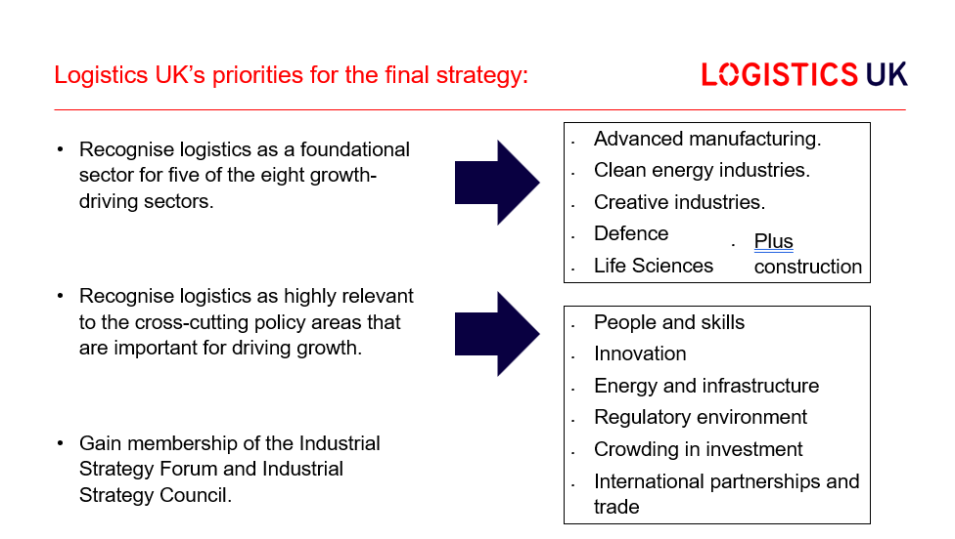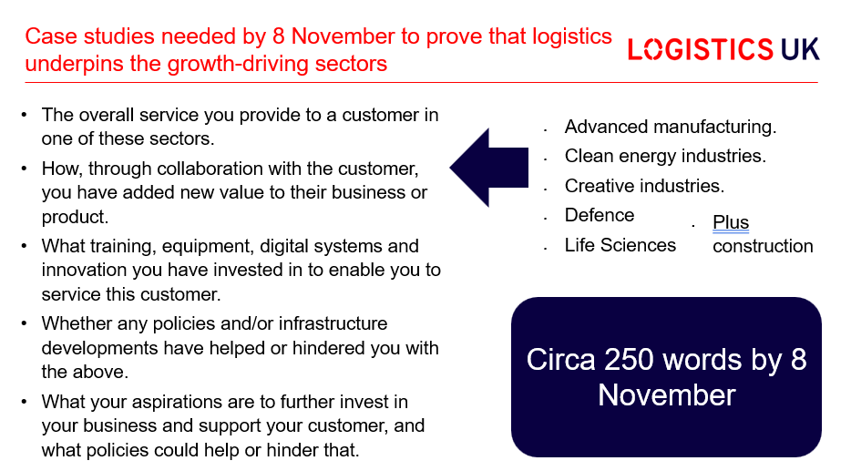

AOB

* JF proposed that future meetings are two hours rather than 90 minutes. Members agree with this suggestion.
* **ACTION:** JF to note, future meetings are to be two hours.

Date for your diary.

* The next meeting of the Customs and Trade Solutions Working Group will be held online on **Wednesday 19 February 11:00 - 13:00**

Attendance:

Mark Johnson (Chair) – Kuehne + Nagel

Ian Moran – EV Cargo

Terry Broadhead – DFDS

Jesse Borghmans – Kuehne + Nagel

Ben Baruch – Amazon

Ian Wilkinson – Royal Mail

Steve Gourley – Momart

Oliver Howell – Hillebrand Gori UK Ltd

Sena Erol – Constantine

Stuart Irwin – Kimberly-Clark Ltd

Zack Lengthorn – Constantine

Josh Fenton (Secretary) – Logistics UK

Ellis Shelton – Logistics UK

Ray Marshall – Logistics UK

Guest Speakers:

HMRC

1. Melanie Southan, Head of Safety and Security Team, Customs Policy & Strategy, Borders and Trade
2. Ieuan Smiton, Customs Technical Policy Advisor & SME, Customs Policy and Strategy, Borders and Trade
3. Emma Hardy, Project Manager, Border Change Delivery, Borders and Trade

Home Office

1. Alex Judge, Safety & Security Lead, Border Policy & International Migration Directorate

Border Force

1. Carol Rayfield, Senior Carrier Account Manager (Maritime), Freight Engagement and Data Acquisition Team (FEDAT)
2. Christopher Hodges, Senior Carrier Account Manager (Data Compliance), Freight Engagement and Data Acquisition Team (FEDAT)